Butter Almond Tart

1 ½ sticks melted butter
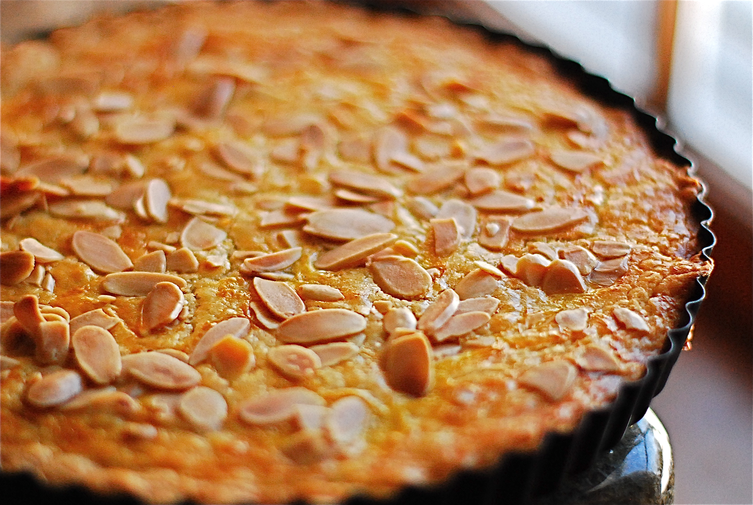
1 ½ cups sugar
2 eggs
2 teaspoons almond extract
2 teaspoons vanilla extract
½ teaspoon salt
1 ½ cups flour
2 tablespoons sliced almonds
2 teaspoons sugar

Preheat oven to 350° F.

Using a mixer, cream together the melted butter and sugar. Beat in the eggs, one at a time.

Add the almond and vanilla extracts. Mix the salt and flour, then add to the butter / sugar / egg mixture.

Grease a 9-inch round pan. Pour in the batter (it will be thick) and spread evenly. Sprinkle with the sliced almonds and sugar.

Bake for 25 to 30 minutes, or until golden brown.

This cake is very dense, with a flavor that is a bit like marzipan. It’s very much a German-style cake.

~ from Jennifer Keith

